Betel

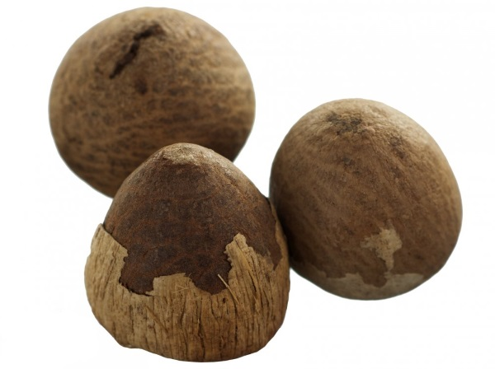

General

The areca tree is a feathery palm that grows to approximately 1.5 m in height and is widely cultivated in tropical India, Bangladesh, Japan, Sri Lanka, south China, the East Indies, the Philippines, and parts of Africa. The tropical palm trees bear fruit all year. The nut may be used fresh, dried, or cured by boiling, baking, or roasting. The quid is a mixture of areca nut, tobacco, and lime wrapped in the leaf of the betel vine (*Piper betel* L. Family: Piperaceae).

(Consume) What is it used for?

The chewing of betel nut quids dates to antiquity. In the 1st century AD, Sanskrit medical writings claimed that betel nut possessed 13 qualities found in the region of heaven. It is pungent, bitter, spicy, sweet, salty, and astringent. It was said to expel wind, kill worms, remove phlegm, subdue bad odors, beautify the mouth, induce purification, and kindle passion. Because of its CNS stimulating effects, betel nut is used in a manner similar to the western use of tobacco or caffeine. Arecoline is responsible for some of the effects of betel quid chewing, such as alertness, increased stamina, a sense of well-being, euphoria, and salivation. Chewing the nut stimulates the flow of saliva to aid digestion. Betel nut also has been used to stimulate the appetite.

Miscellaneous uses

Betel nut's medical use is limited, and long-term negative reactions to betel quid chewing are well known. A decrease in positive symptoms among men with schizophrenia was attributed to betel nut consumption.

What is the recommended dosage?

Limited clinical trials exist to guide dosage; limited clinical uses exist.

How safe is it?

Contraindications

None well documented.

Pregnancy / nursing

Documented adverse reactions, including DNA damage and damage to the fetus. Avoid use.

Interactions

None well documented.

Side Effects

Betel nut consumption has been linked to the incidence of metabolic syndrome.

Toxicities

Areca nut and the betel leaf have caused DNA damage and cancer in cells and in animal experiments. There is a dose- and duration-dependent association of betel quid chewing with precancerous changes in the mouth as well as mouth, throat, laryngeal, and esophageal cancer.

In case of an overdose

Contact the seller

Helpline

contact the seller

Query:

Different packages and solution for RSS feed list

Shredded Baan with leafs

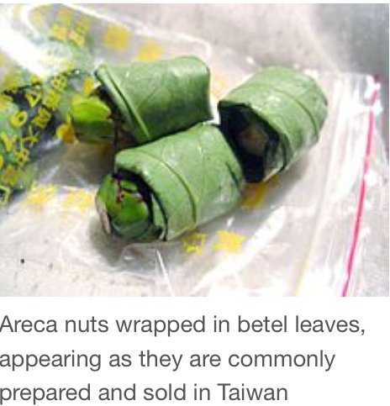

50g bag

100g bag

Carton (100pcs/50g bags)

Carton (100pcs/100g bags)

Shredded Baan

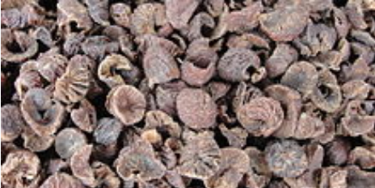

50g bag

100g bag

Carton (100pcs/50g bags)

Carton (100pcs/100g bags)